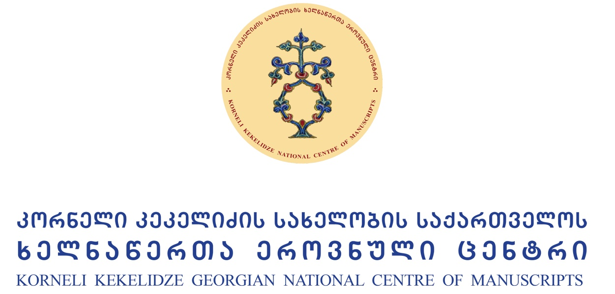

Georgia – Byzantium – Christian East
(Actual Issues of Cultural Relations)

International Conference
call for papers
25–27 September, 2017

Georgian identity among modern European world is defined by the proper definition of its cultural and historic experience in the history of world civilization. The aim of the conference is to prove that the Georgian culture is an essential part of world heritage. Georgian culture of the Middle Ages is an effective participator of the modern World cultural dialogue, as it is the part of common Christian world.
In the context of globalization sharing international scholarly-research experience in the frames of international forum is greatly important. The study of interrelation and influence of Georgian-Byzantine and Christian East cultures in humanitarian studies is prioritized.
Korneli Kekelidze Georgian National Center of Manuscripts (1/3 M. Aleksidze. Tbilisi, Georgia) is organizing the International Conference “Georgia-Byzantium-Christian East” on 25-27 September, 2017.
Conference Languages: Georgian and English.
CVs and abstracts (not more than 500 words max; Georgian texts in AcadNusx, English texts in Times New Roman); English translation should be attached to Georgian texts) should be submitted by e-mail: manuscript.conference@gmail.com
Deadline: June 30, 2017
Successful participants will be informed in the first decade of July.
No registration fee required.
The conference address the themes: philology, history, theology and art history.
I session – Georgia
- Georgia and Christian East in early Middle Ages;
- Georgia and Byzantine Theology;
- Georgia and Byzantine Literature;
- Georgia and Byzantine Art History;
- Artistic Traditions of Christian East in Georgian Culture;
- Georgian Literary Centers of Christian East (Antioch, Palestine, Sinai).

II session – Byzantium
- Theology;
- Literature, literary centers;
- Art History;
- Historiography, Archaeology.

III session – Christian East
- Christian East in early Middle Ages;
- Artistic traditions of Christian East;
- Christian East - historiography, archaeology;
- Literary Centers in Christian East (Antioch, Palestine, Sinai)
- Digital philology

